FSU panama city

EEL 4914C/ 4915C Computer and Electrical Engineering Senior Design II

**SMART Irrigation system – Final report**

## 

## 1. Abstract

This focus of the project is developing a smart irrigation system tailoring watering schedules and run times automatically to meet specific landscape needs. Smart or “precision” irrigation is defined as “a sustainable water saving method for maximizing crop yield and reducing the undesirable environmental impacts from irrigation.” [1]. Smart capability by AI (Machine Learning). A decision tree method will be incorporated as the analytic modeling tool. In this case it will be CHAID, a classification tree that predicts the target variable based on certain rules. The splitting of data is continuous and according to certain factors programmed in. [2]. There are other machine learning algorithms as shown. This will be a home irrigation controller, based on factors such as soil moisture, sunlight, temperature, and humidity. Soil moisture sensor controllers, evapotranspiration controllers, and rain sensors have been shown to save 20%–92%, 20%–71%, and 7%–50% of water, respectively, while maintaining crop growth and quality [1]. Solar panels will be integrated for further efficiency.

## 2. Table of Content

**1. Abstract** **2**

**2. Table Content** **2**

**3. Teams and Teamwork** **3**

**4. Project Selection and Needs Identification** **3**

Needs Identification 3

**5. Requirements Specifications** **4**

Marketing Requirements. 4

Engineering Requirements 6

Strength and weaknesses analysis 10

**6. System Design** **12**

Level 0 Diagram 12

Level 1 Diagram 13

Level 2 Diagram 18

Software Implementation 28

**7. Ethical and Legal Issues** **33**

**8. Conclusion** **33**

## 3. Teams and Teamwork

All 4 members were well versed in all the aspects of the system. Everyone had a hand in the hardware and software of the system and can explain the entire system as such. At the beginning the team decided on the roles listed below, but as stated above, the team was very fluid and were able to adapt and meet the immediate needs of the project that sometimes reach outside the scope of their initial commitments.

## 4. Project Selection and Needs Identification

### Needs Identification

1. Easy to use
2. Affordable
3. Durable
4. Not an eyesore
5. Dependable
6. Integrated net of soil moisture sensors to control overwatering and underwatering in different cycle areas.
7. Energy efficient - solar powered.
8. Atmosphere temperature and moisture sensors controlling watering

during different seasons, or/and during rain, heat or freeze..

1. Friendly user interface.
2. Interactivity - user feedback system
3. Mobile accessibility.
4. Secure (flags activation when assistance is needed)
5. Weatherproof, compact design
6. Noise control solution
7. Integrated AI functionality

## 5. Requirements Specifications

### Marketing Requirements.

1. The system should be intuitive and user friendly in its interface.
2. The system should be affordable.
3. The system should be ruggedized for outdoor year round usage/reliable.
4. The system should be aesthetically pleasing.
5. The system should be energy efficient.
6. The system should offer mobile connectivity.
7. The system should be able to make a decision based on collected data.

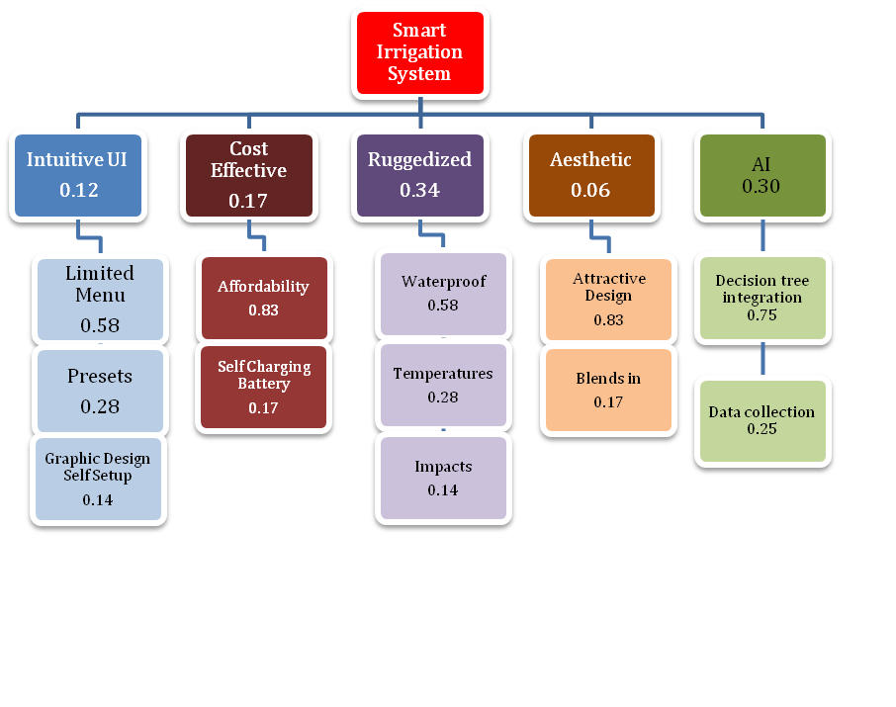

*Fig. 1 Hierarchy of needs - Objective tree*

|  | **Intuitive** | **Ruggedized** | **Cost Effective** | **Aesthetic** | **Score** |
| --- | --- | --- | --- | --- | --- |
| **Intuitive** | 1 | 1/5 | 1/3 | 3 | 0.12 |
| **Ruggedized** | 5 | 1 | 3 | 5 | 0.17 |
| **Cost Effective** | 3 | 1/3 | 1 | 5 | 0.34 |
| **Aesthetic** | 1/3 | 1/5 | 1/5 | 1 | 0.06 |
| **AI** | 5 | 1 | 1/3 | 3 | 0.30 |

Table 1. Pairwise comparison of needs

The need for an automated irrigation system for home gardens has increased as more people begin to grow their own food. 55% of Americans have home gardens and that number continues to grow every year [3]. A system that can be used for this as well as ornamental gardens can meet market demands for home use if they are sufficiently easy to use, maintain, purchase, and meet the visual design goals of the user.

The objective of this project is to prototype an irrigation system for home users that features AI, easy user interactivity, and rugged and aesthetically pleasing design at an effective cost of entry.

### Engineering Requirements

a. **Performance**

* The system will detect moisture in the soil and atmosphere.
* The system will measure ambient temperature.
* The system will make determinations on when and for how long to run the water based on environmental inputs and user presets.

b. **Functionality**

* The system will convert analogue sensor measurements into digital signals.
* The digital signals will be input into a microcontroller that will interpret the data and decide to turn on the water based on machine learning algorithms and user presets.
* The system will implement an easy to read/use UI with limited menu depth.
* The system’s housing should blend in with the environment.

c. **Economic**

* Total parts for production of one prototype will not exceed $500

d. **Energy**

* The system will be operated by a rechargeable battery(s), specs TBD.
* The system will ideally be charged by an integrated solar panel.

e. **Environmental**

* The system should be able to operate within the ambient temperature range of -4˚C to 50˚C.
* The system should be water-resistant.
* The system will be powered by rechargeable battery(s).

a. **Health and Safety**

* The system will shut down if the entenals come into contact with moisture.
* The system will not expose humans to unhealthy levels of electromagnetic radiation and will meet conditions for safe operation identified in ANSI Std. C95.1.

b. **Legal**

* An intellectual property/patent search will be conducted to insure no infringements.

c. **Maintainability**

* All external sensors/components will be modular and be able to be replaced by the user.
* The user will be able to edit the presets to suit the individual needs.

d. **Manufacturability**

* The system will use proprietary PCB and housing, and off-the-shelf sensors, solar panels, and battery(s).

e. **Operational**

* The system should be able to operate within the ambient temperature range of -4˚C to 50˚C.
* The system should be water-resistant.

f. **Political**

* The system will need to gain approval from applicable organizations before sale to the public.
* The software must comply with all applicable copyright regulations.

g. **Reliability & Availability**

* The system will have one year warranty and be user serviceable
* The external sensors, solar panel, and battery(s) will make it easy to obtain OST components.

h. **Social and Cultural**

* The system's manual and menu will be in English and Spanish, with additional languages to come in the future.
* Average time to set up and initialize the system should be no more than an hour.

i. **Usability**

* The system’s UI and manual should be easy to read/understand.
* The system has limited (2-4) menu depth with easy to edit presets.
* The system will have no more than 5 multi-purpose buttons.

| **Marketing Requirements** | **Engineering Requirements** | **Justification** |
| --- | --- | --- |
| 1,4,5 | The system’s UI and manual should be easy to read/understand. | A simple user interface reduces errors while not hindering speed performance. |
| 1,2 | The external sensors, solar panel, and battery(s) will make it easy to obtain OST components. | Competitor design and research shows the product to be utilized by a greater number of people. |
| 3.5 | The system should be able to operate within the ambient temperature range of -4˚C to 50˚C. | The temperature range will allow for functionality within most conditions seen by the user. |
| 4 | The system’s housing should blend in with the environment. | The housing will blend into the environment and not be an eye-sore for the user. |
| 2,3 | The system should be water-resistant. | Water-resistance will keep the system functioning under certain conditions which will lead to less money spent over the life of the device. |
| 1,2 | All external sensors/components will be modular and be able to be replaced by the user. | Using OST items will be cheaper and easier for the user to obtain and install. |
| **Marketing Requirements**   1. Intuitive usability 2. Cost Effective 3. Ruggedized 4. Aesthetic 5. AI | | |

*Table 5.1 Smart irrigation systems requirements. Marketing requirements are listed at the end of the table.*

| **User Interface** | **Display** | **Connectivity and expansion** | **Power** | **Modularity** | **Size** |
| --- | --- | --- | --- | --- | --- |
| Touchpad | LCD | USB | Battery | Simple PVC sprinkler | Credit Card size |
| App | Plasma | Serial/Parallel | Solar Panels | Add on quick connect valve for lines/drip | Notebook size |
| Voice | Analog | Wireless | AC Power | Sprinkler using recycled materials | 16 inch |
| Buttons | LED | Bluetooth | Thermal transfer | Pump add-ons ie rainbarrel | Laptop size |
|  |  | AI | Fuel cell | Separate components of basic system into modules | Car size |

*Table 6.1 A concept table for generating ideas for a SMART irrigation system The potential solution is identified by the combination of red colored elements*

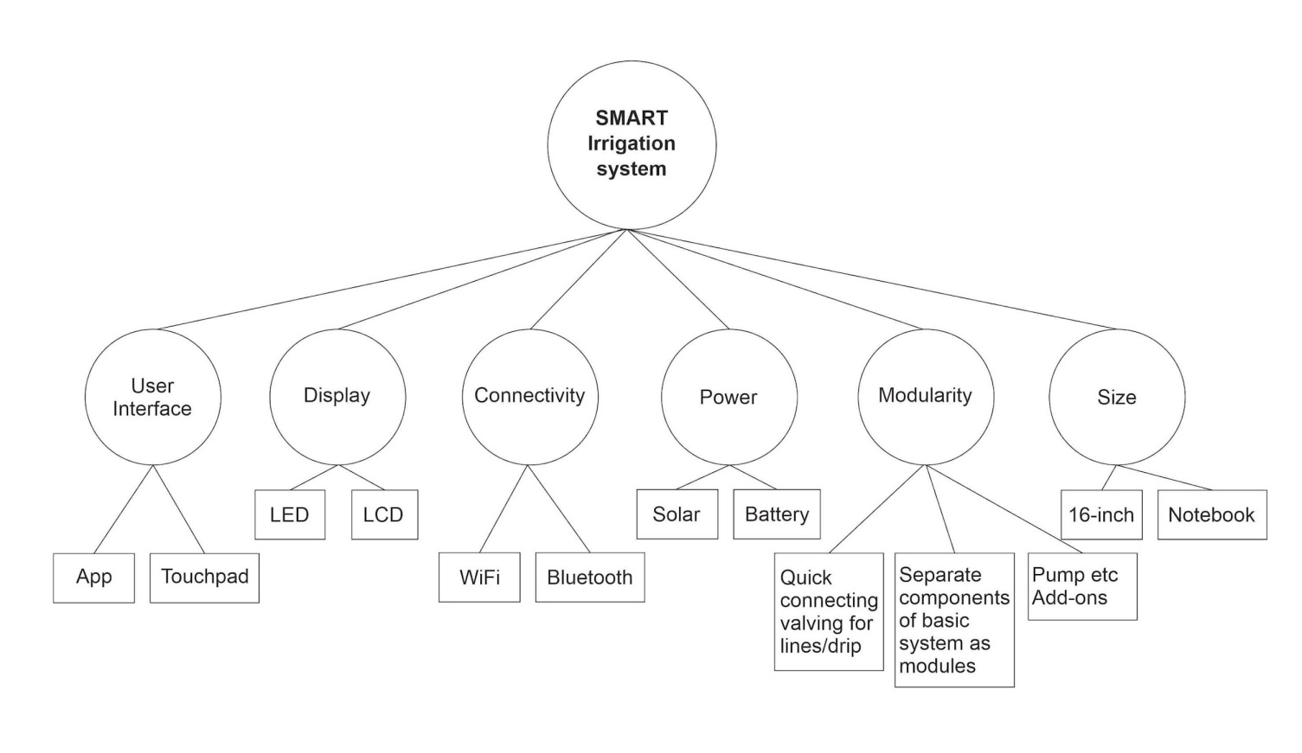

*Figure 6.1 Concept fan for a SMART irrigation system. Circle boxes represent the choices to be made and square ones represent potential solutions to the choices*

1. **- Initial evaluations - o**bserving Table 6.1 and Figure 6.1, the following conclusions are drawn:
   * 1. - **User Interface** - only the touchpad meets all engineering requirements. Voice and App integration will require additional components, which will make it cost inefficient. Buttons will change the aesthetic requirement.
     2. **- Display** - LED and LCD are more cost effective and use less power, compared to plasma and analog. Analog will become more complex for implementation.
     3. **- Connectivity and expansion** - Wireless and Bluetooth are faster and easier to install, require less equipment and are more convenient.
     4. **- Power** - The external sensors, solar panel, and battery(s) will be easy to obtain OST components.
     5. **- Modularity** - Separating the components from a dense all in one system will save space, money, and be easier to design as modules. It will also allow upgradability, expansion =, and allow repairs to be made at the module level easily.
     6. **- Size** - Based on the components available on the market, and requirements and needs identified previously, the size of the SMART irrigation system will exceed the size of a credit card, or potentially the notebook size. Most suitable size will fall under the category of a about 16-inch display size, which is the general size of a laptop.

### Strength and weaknesses analysis

| **User Interface** | **Strengths** | **Weaknesses** |
| --- | --- | --- |
| **Touchpad** | *-Size vs screen and buttons, accuracy of selection, simplicity*  *-Does not require network connection* | *-Icons must be large enough*  *-Cleanliness,*  *-Durability* |
| **App** | *-Could be used and operated through a mobile device*  *-Higher productivity* | *-Requires extra device*  *-Requires network connection*  *-Mobile versions differ from physical devices versions* |

1. *Table 6.2.1 A strengths and weaknesses analysis of User Interface*

| **Display** | **Strengths** | **Weaknesses** |
| --- | --- | --- |
| **LED** | *-20-30% better power consumption*  *-Better quality*  *-High definition output*  *-Longer life* | *-Harder to find* |
| **LCD** | *-Availability online*  *-Variety of sizes* | *-More power consumption*  *-Shorter life* |

1. *Table 6.2.2 A strengths and weaknesses analysis of Display*

| **Connectivity** | **Strengths** | **Weaknesses** |
| --- | --- | --- |
| **Bluetooth** | *-Less power consumption*  *-Excellent range* | *-Distance dependency*  *-Reduced speed transfer* |
| **Wireless** | *-Faster connection*  *-Better wireless security* | *-Dependent on network connectivity*  *-Requires more power* |

1. *Table 6.2.3 A strengths and weaknesses analysis of Connectivity*

| **Power** | **Strengths** | **Weaknesses** |
| --- | --- | --- |
| **Battery** | *-Constant supply of power*  *-More compact*  *-More cost effective* | *-Recharging*  *-Shorter lifetime* |
| **Solar** | *-Self sustaining*  *-Low maintenance*  *-Pollution-free* | *-Lack of sunlight*  *-High initial start up*  *-Used a lot of space* |

1. *Table 6.2.4 A strengths and weaknesses analysis of Power*

| **Modularity** | **Strengths** | **Weaknesses** |
| --- | --- | --- |
| **Quick connect hoses/lines** | *-Easy to use*  *-Streamlines adding on*  *-More cost effective* | *-Only connect one way*  *-Limits initial choices of hose/tube sizes* |
| **Adds on separate (pumps, rain barrels, etc)** | *-Keeps systems small*  *-Allows expansion later*  *-Replaceability* | *-More to buy later,*  *-Requires planning to expand* |
| **Basic components as modules** | *-Keeps startup simple*  *-Less costly basic kits*  *-Replaceability*  *-Smaller components* | *-More pieces*  *-Distances over network/protocol*  *-Troubleshooting* |

1. *Table 6.2.5 A strengths and weaknesses analysis of Modularity*

| **Size** | **Strengths** | **Weaknesses** |
| --- | --- | --- |
| **Notebook** | *-More compact*  *-Lighter* | *-Less functional* |
| **16 inch** | *-Will improve functionality*  *-Better visualization* | *-More cumbersome*  *-Heavier* |

1. *Table 6.2.6 A strengths and weaknesses analysis of Size*

## 6. System Design

In this section, the group used functional decomposition and level 0 and level 1 diagrams to determine the components and their connections to the system.

#### Level 0 Diagram

| Model | SMART Irrigation system |
| --- | --- |
| Input | * Power - 12V Battery (charged by solar). * Environmental inputs (Moisture Level, Relative Humidity, Ambient Temperature, Light) * Touch panel control (user input) |
| Output | * Water from solenoid * LCD Display |
| Functionality | * Receive input signals from environment, process data and generate output signal to open and close solenoid |

*Table 7.1 Level 0 SMART Irrigation system functionality*

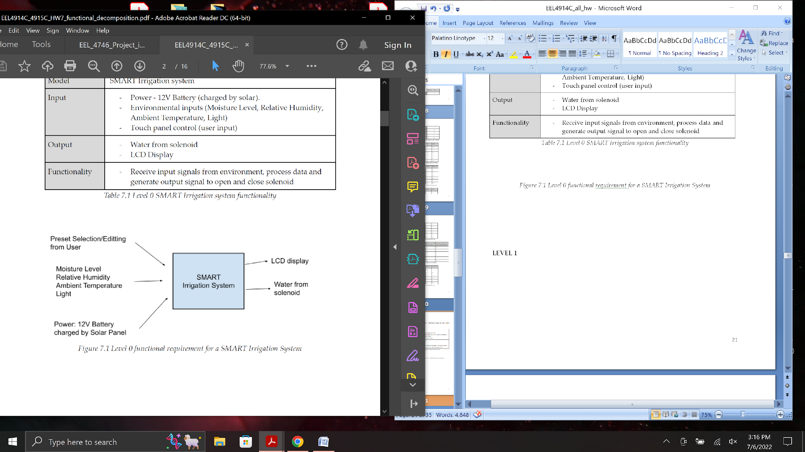

*Figure 7.1 Level 0 functional requirement for a SMART Irrigation System*

**Level 1 Diagram**

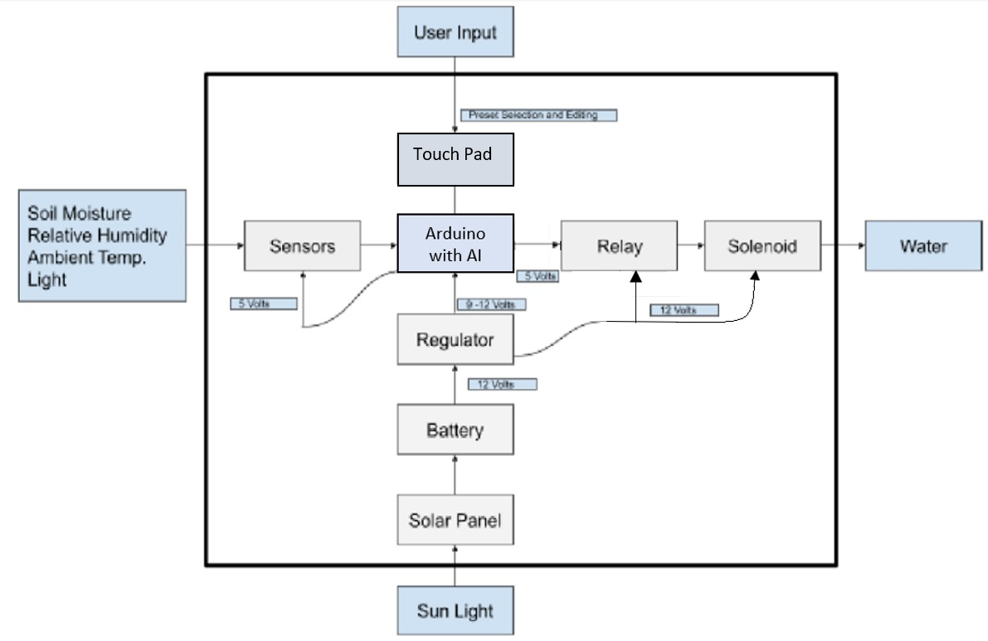

*Figure 7.2 Level 1 diagram of a SMART Irrigation System - Iteration 1*

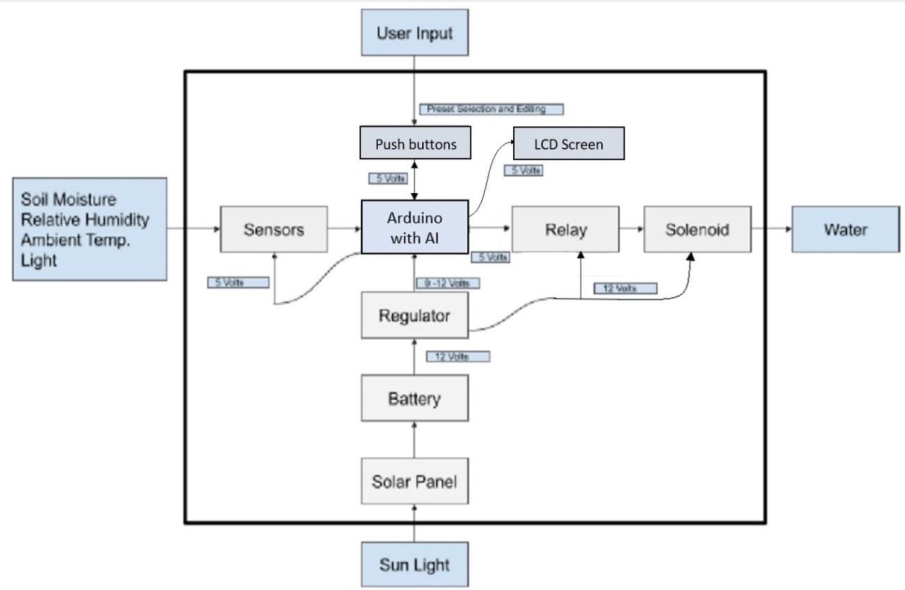

*Figure 7.2 Level 1 diagram of a SMART Irrigation System - Iteration 2*

| Model | **Humidity sensor** |
| --- | --- |
| Input | - Powered by 5V port on Arduino  - Humidity value |
| Output | Digital signal |
| Functionality | Measures humidity level and sends a signal to Arduino |

*Table 7.2.1. Level 1 Humidity sensor functionality*

| Model | **Temperature sensor** |
| --- | --- |
| Input | - Powered by 5V port on Arduino  - Temperature value |
| Output | Digital signal |
| Functionality | Measures temperature level and sends a signal to Arduino |

*Table 7.2.2. Level 1 Temperature sensor functionality*

| Model | **Soil moisture sensor** |
| --- | --- |
| Input | - Powered by 5V port on Arduino  - Moisture value |
| Output | Voltage signal |
| Functionality | Output voltage is a function of the soil moisture, sends signal to Arduino |

*Table 7.2.3. Level 1 soil moisture sensor functionality*

| Model | **Light sensor** |
| --- | --- |
| Input | - Powered by 5V port on Arduino  - Sun light |
| Output | Voltage signal |
| Functionality | Output voltage is a function of the light, sends a signal to Arduino |

*Table 7.2.4. Level 1 Light sensor functionality*

| Model | **Arduino** |
| --- | --- |
| Input | - Power 12V DC  - Signals from sensors  - User Input |
| Output | **-** Sends signal to open/close solenoid |
| Functionality | Process the received signals from sensors, make determinations to turn on/off solenoid |

*Table 7.2.5. Level 1 Arduino functionality*

| Model | **Relay** |
| --- | --- |
| Input | - Powered by 12V port on regulator  - signal from Arduino |
| Output | Voltage |
| Functionality | Relays signal from Ardunio to Solenoid |

*Table 7.2.6. Level 1 relay functionality*

| Model | **Solenoid** |
| --- | --- |
| Input | - Signal from relay |
| Output | - Water |
| Functionality | - Opens and closes valve for water |

*Table 7.2.7. Level 1 solenoid functionality*

| Model | **Regulator** |
| --- | --- |
| Input | - Voltage from Battery |
| Output | - Regulated 12V |
| Functionality | - Regulates voltage from battery |

*Table 7.2.8. Level 1 regulator functionality*

| Model | **Battery** |
| --- | --- |
| Input | - Solar Panel |
| Output | - 12V DC |
| Functionality | - Powers the system |

*Table 7.2.9. Level 1 battery functionality*

| Model | **Solar panels** |
| --- | --- |
| Input | Sun light |
| Output | Voltage to charge battery |
| Functionality | Uses sunlight to charge battery |

*Table 7.2.10. Level 1 solar panels functionality*

| Model | **Touch Pad** |
| --- | --- |
| Input | Users Touch |
| Output | Digital Signal |
| Functionality | Allows for selection and editing of presets |

*Table 7.2.11. Level 1 solar panels functionality*

| Model | **LCD signal** |
| --- | --- |
| Input | signal from the switch |
| Output | Digital Signal |
| Functionality | Display the values |

*Table 7.2.12 Level 1 LCD functionality*

#### Level 2 Diagram



*Figure 7.3.1 Level 2 diagram of a SMART Irrigation System - Iteration 1*



*Figure 7.3.2 Level 2 diagram of a SMART Irrigation System - Iteration 2*

| Model | **Humidity and temperature sensor (The DHT-22 Sensor)** |
| --- | --- |
| Input | - Powered by 5V port on Arduino  - Humidity value |
| Output | Digital signal |
| Functionality | -Measures humidity level and sends a signal to Arduino  -Measures temperature level and sends a signal to Arduino |

*Table 7.3.1. Level 2 Humidity and temperature sensor functionality*

| Model | **Soil moisture sensor (Waveshare Moisture Detection Sensor Module)** |
| --- | --- |
| Input | - Powered by 5V port on Arduino  - Moisture value |
| Output | Voltage signal |
| Functionality | Output voltage is a function of the soil moisture, sends signal to Arduino |

*Table 7.3.2. Level 2 soil moisture sensor functionality*

| Model | **Light sensor ( Photoresistor Photo Light Sensitive Resistor Light Dependent Resistor 5 mm GM5539 5539)** |
| --- | --- |
| Input | - Powered by 5V port on Arduino  - Sun light |
| Output | Voltage signal |
| Functionality | Output voltage is a function of the light, sends a signal to Arduino |

*Table 7.3.3. Level 2 Light sensor functionality*

| Model | **Arduino (UNO R3)** |
| --- | --- |
| Input | - Power 12V DC  - Signals from sensors  - User Input |
| Output | **-** Sends signal to open/close solenoid |
| Functionality | Process the received signals from sensors, make determinations to turn on/off solenoid |

*Table 7.3.4. Level 2 Arduino functionality*

| Model | **Relay ( HiLetgo 2pcs 5V One Channel Relay Module Relay Switch with OPTO Isolation High Low Level Trigger)** |
| --- | --- |
| Input | - Powered by 12V port on regulator  - signal from Arduino |
| Output | Voltage |
| Functionality | Relays signal from Ardunio to Solenoid |

*Table 7.3.5. Level 2 relay functionality*

| Model | **Solenoid (HFS(R) 12v Dc Electric Solenoid Valve Water Air Gas, Fuels N/c - 1IN NPT Available (12V DC 1IN NPT)** |
| --- | --- |
| Input | - Signal from relay |
| Output | Water |
| Functionality | Opens and closes valve for water |

*Table 7.3.6. Level 2 solenoid functionality*

| Model | **Topsolar Solar Panel** |
| --- | --- |
| Input | - Sun Light |
| Output | - Voltage to the battery |
| Functionality | -Uses sunlight to charge battery |

*Table 7.3.7. Level 2 solar panel functionality*

| Model | **Touch Pad: 2.8" TFT LCD TOUCHSCREEN (not used in a final project)** |
| --- | --- |
| Input | Users Touch |
| Output | Digital Signal |
| Functionality | Allows for selection and editing of presets |

*Table 7.3.8. Level 2 solar panels functionality*

| Model | **Regulator: LM2596** |
| --- | --- |
| Input | - Voltage from Battery |
| Output | - Regulated 12V |
| Functionality | - Regulates voltage from battery |

*Table 7.3.9 Level 2 regulator functionality*

| Model | **16x2 White on Blue Character LCD** |
| --- | --- |
| Input | signal from the switch |
| Output | Digital Signal |
| Functionality | Display the values |

*Table 7.3.9 Level 2 LCD functionality*

| Model | **UT-1272-F1 12V 7 Ah Battery** |
| --- | --- |
| Input | Voltage from solar pannel |
| Output | 12 Volts |
| Functionality | Power the system |

*Table 7.3.9 Level 2 battery functionality*

**4) Pictures of the used components.**

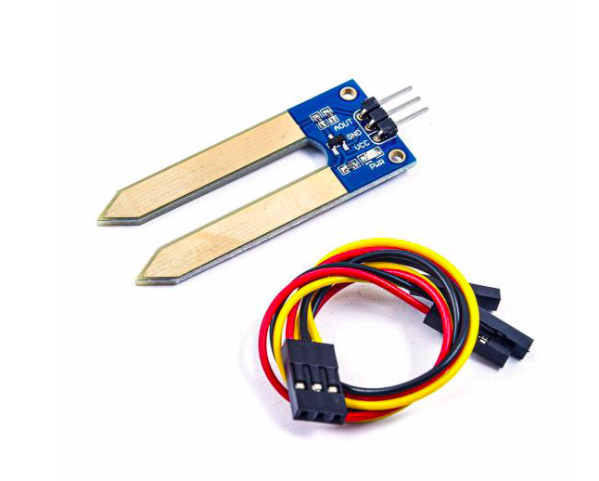

*Figure 7.4.1. Waveshare Moisture Detection Sensor Module(Soil moisture)*

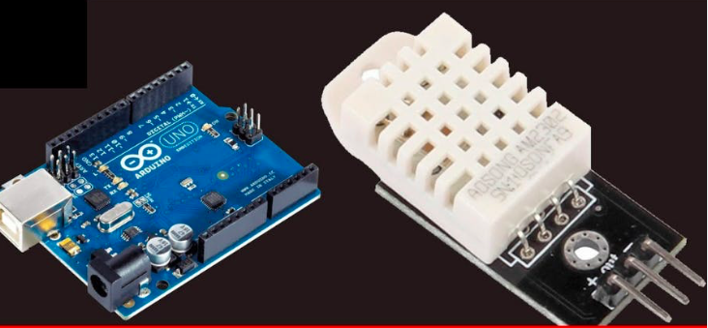

*Figure 7.4.2. The DHT-22 Sensor (temp/ H)*

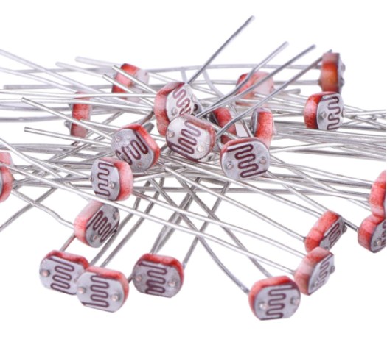

*Figure 7.4.3. Photoresistor Photo Light Sensitive Resistor Light Dependent Resistor 5 mm GM5539 5539*

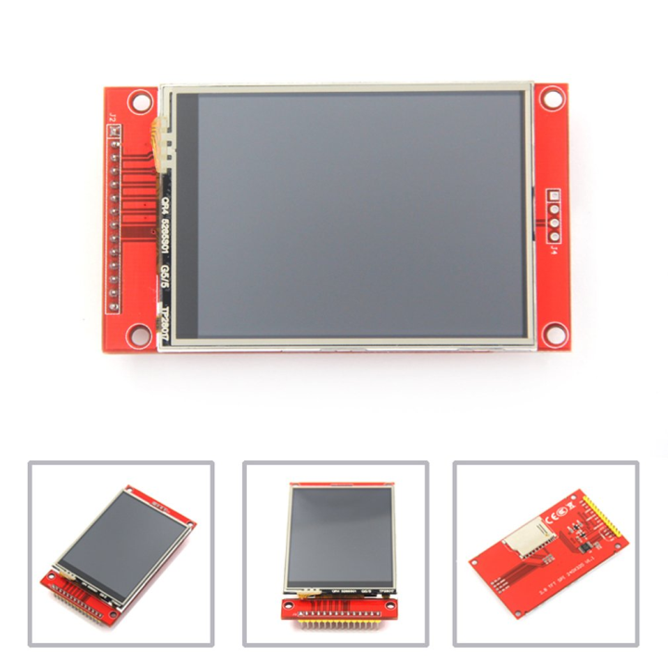

*Figure 7.4.3. 2.8" TFT LCD TOUCHSCREEN with SD slot*

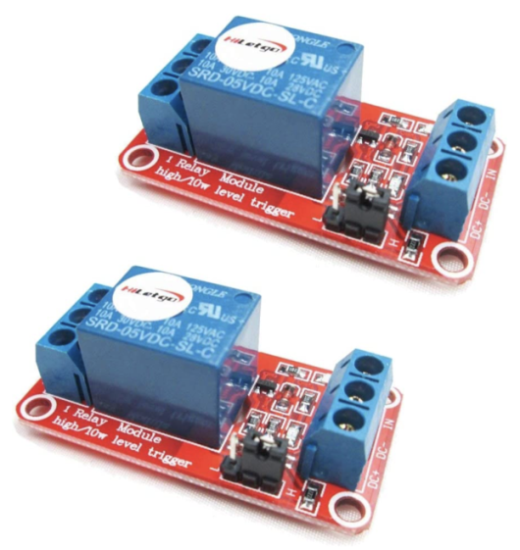

*Figure 7.4.4. HiLetgo 2pcs 5V One Channel Relay Module Relay Switch with OPTO Isolation High Low Level Trigger*

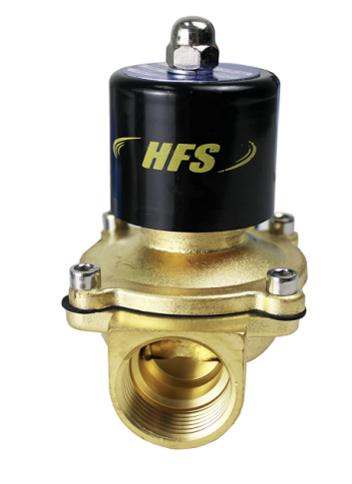

*Figure 7.4.5. HFS(R) 12v Dc Electric Solenoid Valve Water Air Gas, Fuels N/c - 1IN NPT Available (12V DC 1IN NPT)*

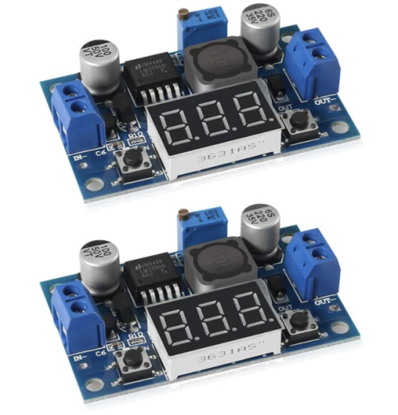

*Figure 7.4.6. LM2596 Adjustable Voltage Regulator 4.0-40V to 1.25-37V DC 36V to 24V to 12V to 5V Variable Volt Power Supply Car Motor Buck Step Down Converter*

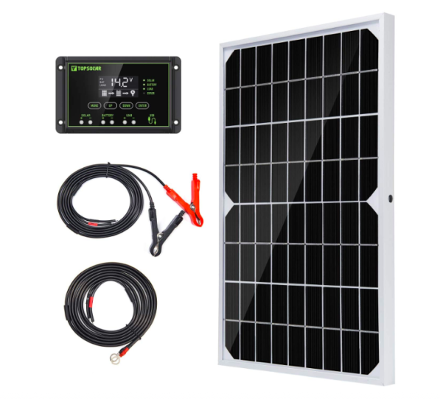

*Figure 7.4.7. Topsolar Solar Panel Kit 10W 12V Monocrystalline with 10A Solar Charge Controller*

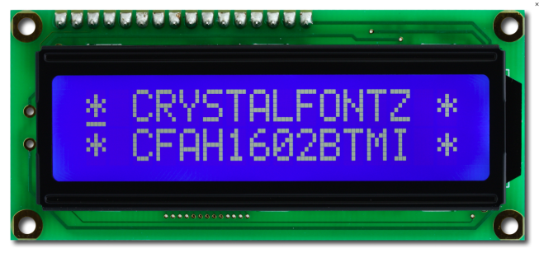

*Figure 7.4.13 16x2 White on Blue Character LCD*

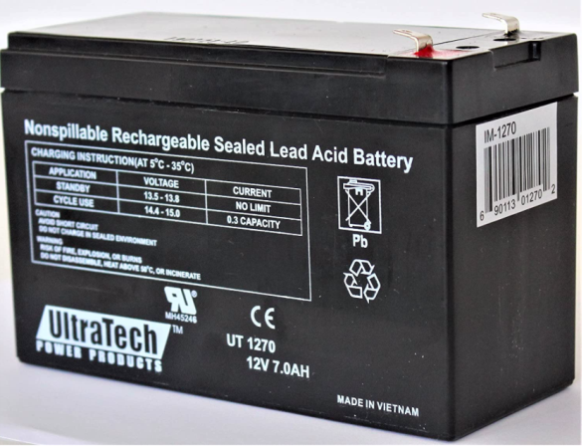

*Figure 7.4.14 UltraTech UT1270 / UT-1272-F1 12V 7 Ah Sealed Lead Acid Alarm Battery UT-1270 UT-1272-F1*

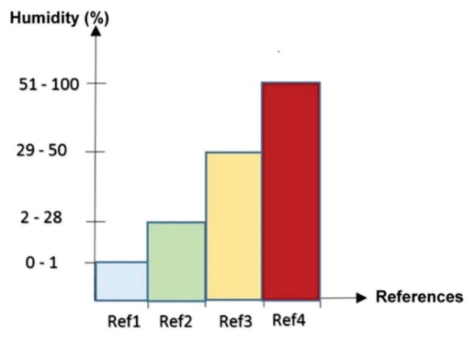 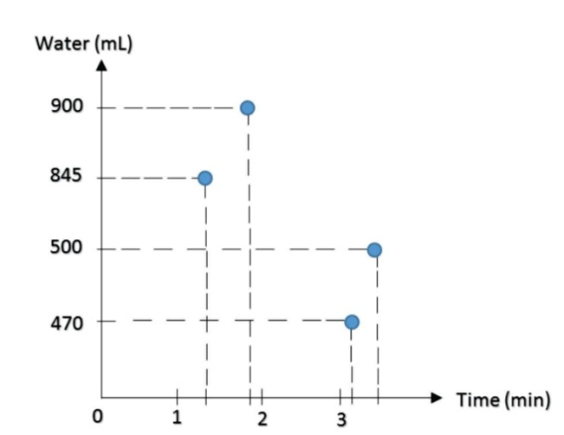

*Figure 7.5.1 Humidity levels and references Figure 7.5.2 Water amount vs time needed*

### Software Implementation

Machine learning is the scientific study of algorithms and statistical models that computer systems use to perform a specific task without using explicit instructions, relying on patterns and inference instead. It is seen as a subset of artificial intelligence. AI algorithms build a mathematical model based on sample data, known as "training data", in order to make predictions or decisions without being explicitly programmed to perform the task.

In this project we aim to achieve a Smart Irrigation system with AI functionality, which offers a certain level of automation by taking in parameters like temperature, humidity, soil moisture, and light and then predicting the future values and according to these predictions controlling the on/off process. To achieve this goal a decision tree algorithm needs to be implemented. The purpose of using a Decision Tree is to create a training model that can be used to predict the class or value of the target variable by learning simple decision rules inferred from prior data (gathered training data). In Decision Trees, for predicting a class label for a record, we start from the rootof the tree. Each node in the tree acts as a test case for a specific attribute, and each edge descending from the node corresponds to the possible answers to the test case. This process is recursive in nature and is repeated for every subtree rooted at the new node.

All developed code sketches for testing purposes of each sensor and part of the system are attached as individual files. then a final code for the Irrigation system with added AI functionality is generated. And lastly the second design project code is also attached separately. All codes are commented on for better understanding.

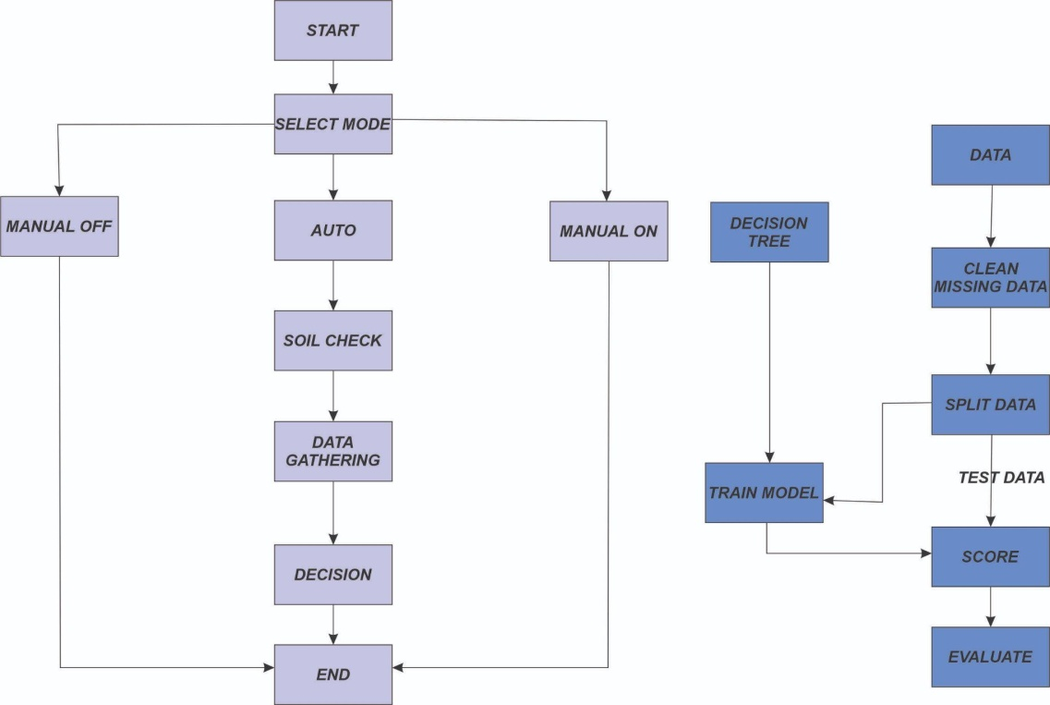

*Figure 7.4.1 Data Flow Diagram*

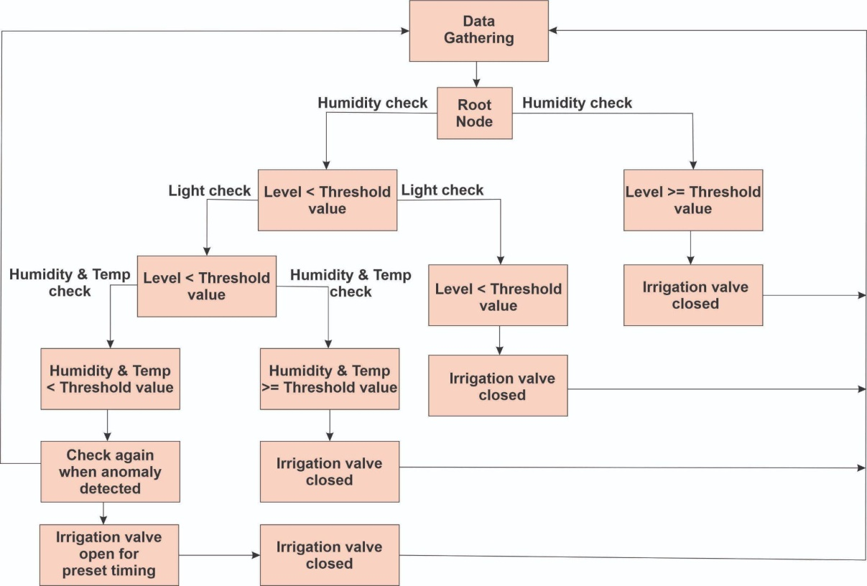

*Figure 7.4.2 Decision tree*

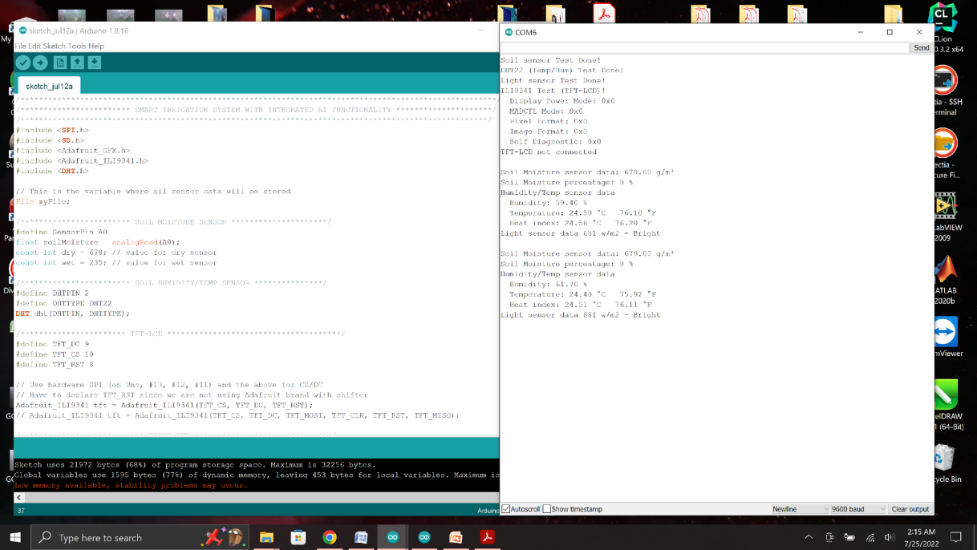

*Figure 7.4.4 Serial output of measured sensor values*

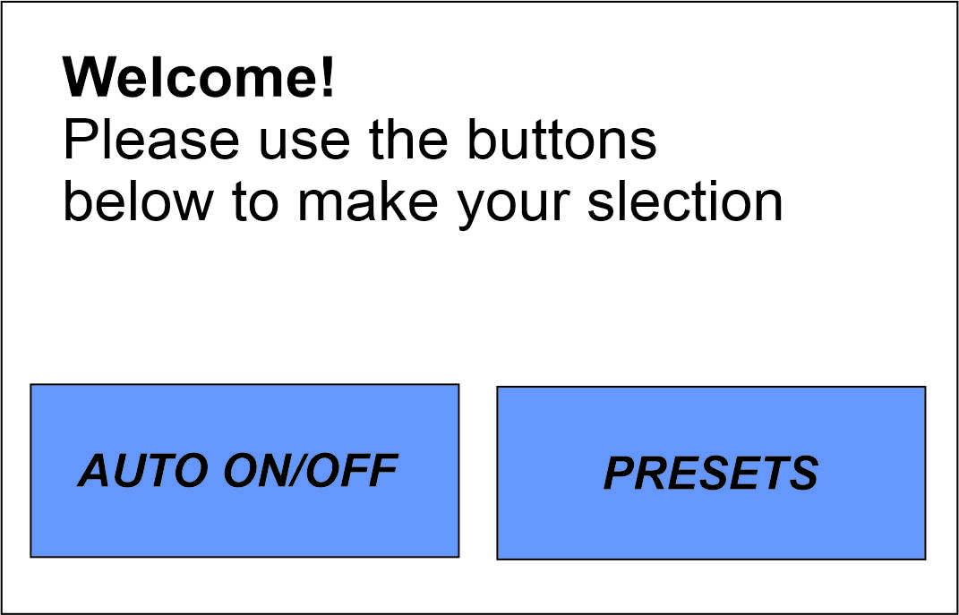

*Figure 7.4.3 Display UI for user touch input*

**Pin connections**

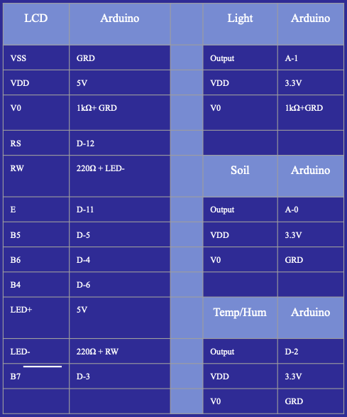

*Table 7.5.4 Pin connections of LCD display, Light, Soil, Temp/Humidity sensors*

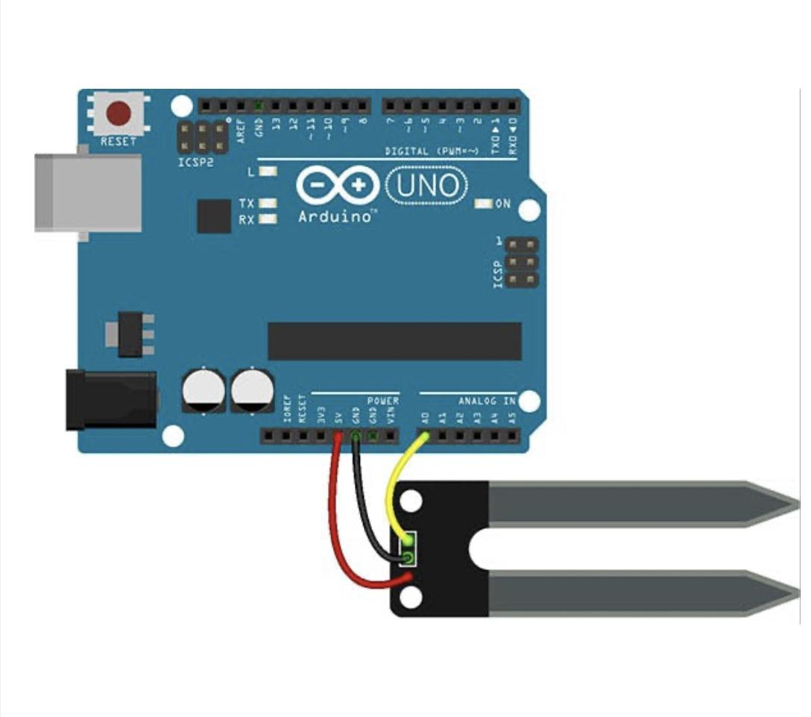

*Figure 7.5.1 Pin connection of Soil moisture sensor*

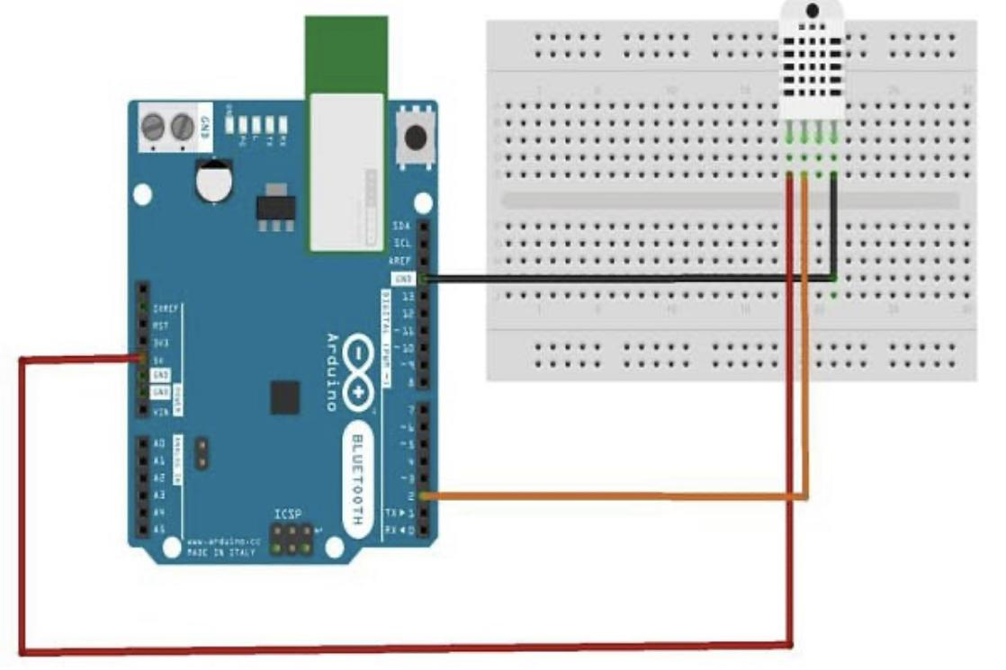

*Figure 7.5.2 Pin connection of temperature and humidity sensor*

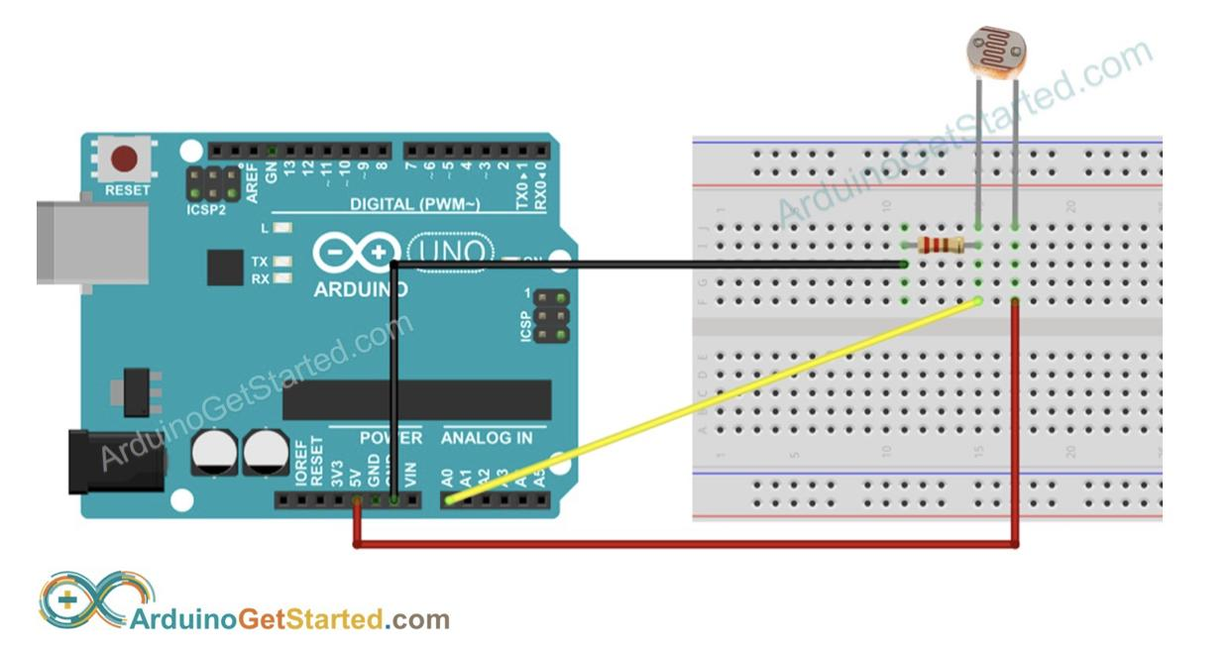

*Figure 7.5.3 Pin connection of light sensor*

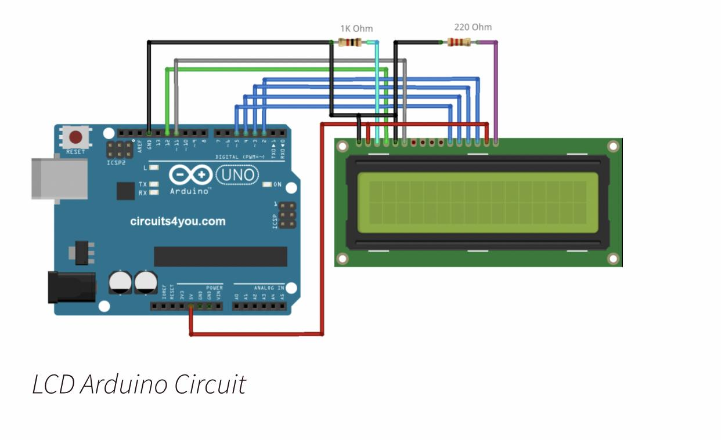

*Figure 7.5.4 Pin connection of LCD display*

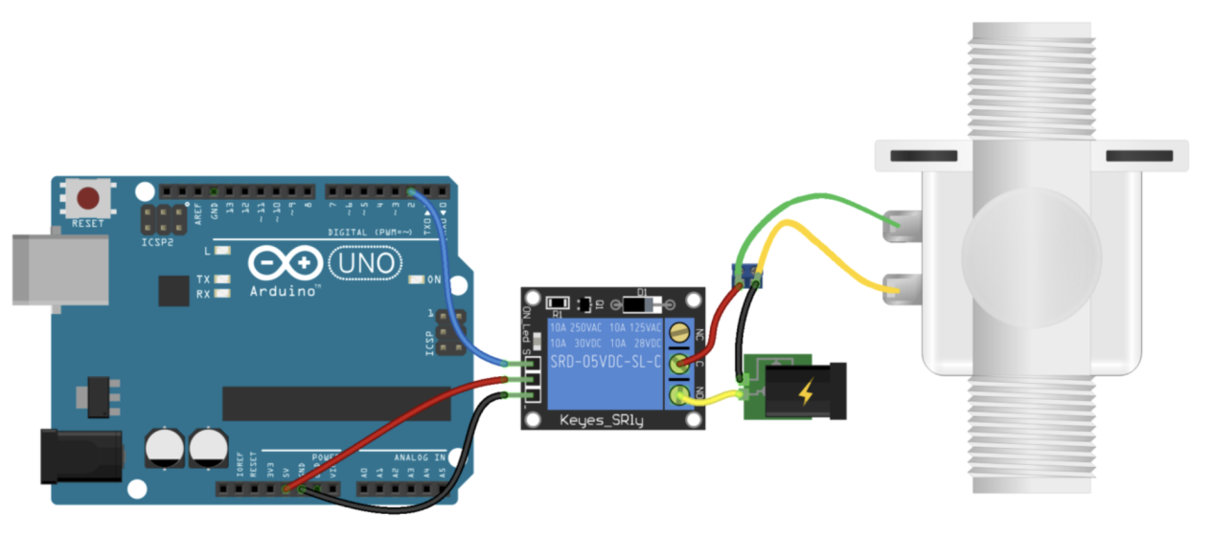

*Figure 7.5.5 Pin connection of solenoid*

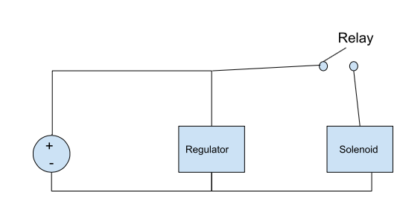

*Figure 7.5.7 Parallel connection of regulator, 12V battery, and solenoid (controlled by the relay)*

## 7. Ethical and Legal Issues

Although this section was not discussed in detail due to time restraints, the Engineering Requirements section listed items pertaining to these topics ie... Economics, Energy, Environmental, Health and Safety, Legal, Political, and Social and Cultural.

Failure Mode and Effects Analysis (FMEA) is a structured way to identify and address potential problems, or failures and their resulting effects on the system or process before an adverse event occurs. The following table evaluates a number of potential failures, their effect and suggested actions.

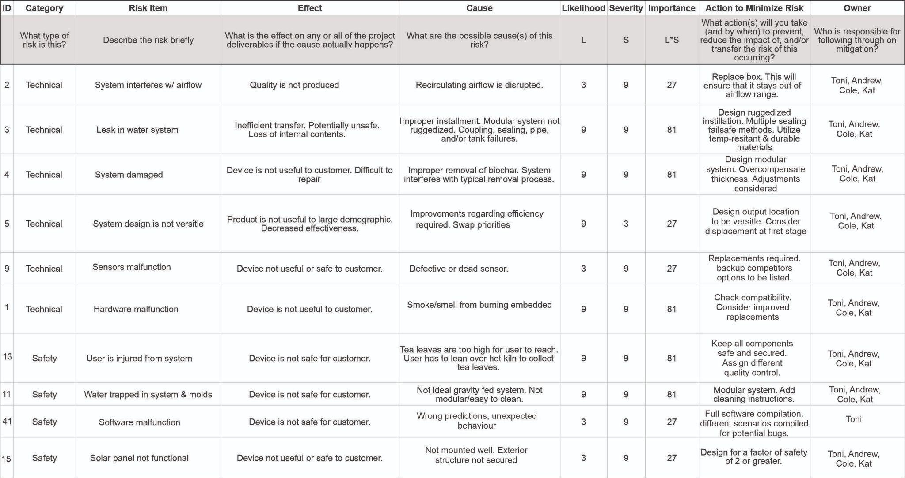

*Table 7.5.4 Failure Mode and Effects Analysis (FMEA) of a Smart Irrigation system*

## 8. Conclusion

During the process of development, testing, and troubleshooting, the team incurred setbacks as with any newly designed system. The AI implementation was not able to be uploaded to the device at the time because the data storage unit was damaged. Also, the touchpad was damaged which limited the user's ability to input commands into the device. However, the group was able to realize a prototype and managed to effectively demonstrate the physical functionality of the designed system on time. This was demonstrated by looping through the code to show the readout of the device sensors on the LCD as well as via the serial monitor of the arduino IDE.

An AI algorithm was still created and included in the report to demonstrate the potential had the group not damaged the initial iteration of the system. Machine learning and data analytics have begun to make advancements in the field of agriculture as the precision offered has allowed the consumption of water to decrease versus conventional methods. Unfortunately , the Arduino Uno R3 board that was sourced in this project has very limited memory on board for this type of application. AI requires storage to both collect data and to process it; for this purpose an improvement that could be made would be to use either an Arduino Mega or a Raspberry-Pi based microcontroller with more built in storage to prevent the issue of running out of space. Both systems offer sensor components with utilities built in for easy interfacing. This will be discussed below.

On a hardware level, the integration of more sensors, such as rain sensor, different area moisture sensors, rain container with level sensor, water waste reduction sprinklers, etc could significantly improve the performance of the system. Monitoring system is also included in the list of future enhancements. To improve upon the system, one such monitoring system would be to implement a vision system to discriminate between the crops and any weeds that may be growing, as well as to look for blight among crops. Manual weed extraction and identification is a time consuming process and automation of this would help keep a healthy, weed free garden. Further monitoring systems would include any out of parameter levels of variables, which AI could normalize.

One way of future improvements could involve an upgrade of the Arduino Uno R3 board with a higher generation Arduino Mega board. This way memory issues will be resolved since Uno provides 32KB flash memory, compared to Mega and its 256KB. The following libraries for data processing will also be applicable:

<https://www.arduino.cc/reference/en/libraries/category/data-processing/>

Another way to go is considering the involvement of a Raspberry Pi board. While Arduino boards are micro-controllers, Raspberry Pi boards are microprocessors, which have their own operating system. For a single-purpose project Arduino is the better option, since it is cost-friendly but has a trade off of clock speed in MHz . However, in multi-purpose applications, Raspberry Pi would be a better choice due to GHz clock speed, better processor, and is good for developing software applications using Python. The Pi would bring an increase in efficiency as efficiency is a metric of time, i.e. “how many tasks in a time period?” The faster processing would also be optimal for the real time decisions required for the system.

Furthermore, with either of these more advanced microcontrollers, it would be much easier to create the wireless system of sensors envisioned in the early stages of development by the group. Mobile App integration is another potential future add-on to the system. The wireless connectivity allows users to leverage the efficiency of the data analytics offered by the AI over a larger area to be irrigated. The internet of things (IoT), a concept that joins wireless and mobile tools embedded via the internet, can be combined with the sensors of the system to optimize watering and soil management in real-time. These systems are generally easier to operate as they allow user access remotely. This concept is not limited to the gardening system of the original design and could be implemented in some form anywhere water management is needed.

There are many more different aspects and potential improvements that could be applied into this system, based on specific needs and applications. Of course, the trade off for a better and more advanced functionality is increased cost effectiveness.While the implementation of better features offers improvements in function, one of the original needs was identified as being cost efficient, ergo the original design reflected that in the concepts. The solution was identified as the system having multiple levels of offerings, with a smaller basic system that could be expanded upon later, thus achieving a cost effective product and still offering salient features through expansion via later purchases by the consumer.

In conclusion, the project was a success as the group was able to design, create, and troubleshoot not one but two separate systems for irrigation control. Last minute technical issues improved participants' critical thinking, problem solving and teamwork. While AI was not able to be implemented in these due to device constraints and incidents, the framework is there in the code that will be submitted. Future troubleshooting should yield a robust, user friendly, cost effective AI enabled system.